SOFTWARE REQUIREMENTS SPECIFICATION
STUDENT RECORD SYSTEM
Version 1.0 | Programming Language: C / C++

Team Members
SRN | Name
PES2UG24CS353 | Poorvika V
PES2UG24CS342 | Pattamsetty Abhay Babji
PES2UG24CS328 | Nitya Kushwaha
PES2UG24CS327 | Nitin Somisetty

Revision History
Version | Date | Author(s) | Change Summary
1.0 | 04-09-2026 | Project Team | Initial SRS

Table of Contents
- 1. Introduction
- 2. Overall Description
- 3. External Interface Requirements
- 4. System Features (Detailed)
- 5. Non-Functional Requirements
- 5.1 Security
- 6. Quality Attributes & Acceptance Tests
- 7. UML Use-Case Diagram
- 8. Requirements Traceability Matrix (RTM)

1. Introduction

1.1 Purpose
This Software Requirements Specification (SRS) defines the functional, non-functional, and security requirements of the Student Record System (SRS). The system provides a centralized, reliable environment for maintaining student academic records, including grades, attendance, personal details, and performance reports, for use by academic institutions.

1.2 Scope
The platform covers student registration and profile management, grade entry and computation, attendance tracking, report generation, and role-based access for students, faculty, and administrators. It is implemented in C/C++ and does not cover financial transactions, online learning modules, or live examination proctoring.

1.3 Audience
Students, faculty members, administrators, developers, testers, and project evaluators.

1.4 Definitions
Term | Definition
Student Record | A persistent data entry containing a student's personal, academic, and attendance details.
Grade | A numeric or letter value assigned to a student for a course based on assessment performance.
Attendance | A daily or per-session record of a student's presence or absence in a course.
Faculty | An authorized instructor who can enter and manage grades and attendance for their courses.
Administrator | A privileged user responsible for managing user accounts, courses, and system configuration.
GPA / CGPA | Grade Point Average / Cumulative GPA, computed from course grades and credit weights.
Report | A structured summary of a student's academic and attendance data for a given period.

2. Overall Description

2.1 Product Perspective
The Student Record System is a standalone C/C++ application with a command-line or lightweight GUI interface and a file-based or embedded relational database for persistent storage. It replaces manual registers and scattered spreadsheets with a unified system in which student profiles, grades, attendance, and reports are consistently managed.

2.2 Major Product Functions
- Student registration, profile creation, and personal data management
- Course and section management
- Grade entry, modification, and GPA/CGPA computation
- Attendance recording and percentage calculation
- Academic report generation (per student, per course, per semester)
- Role-based access control for students, faculty, and administrators
- Search and filter across student records

2.3 User Roles and Characteristics
Role | Main Capabilities
Student | View own profile, grades, attendance records, and generated reports.
Faculty | Enter and update grades and attendance for assigned courses; view course-level summaries.
Administrator | Manage all student profiles, user accounts, course assignments, and system data; generate institution-wide reports.

2.4 Operating Environment
- Desktop computer running Windows 10/11 or Linux (Ubuntu 20.04+)
- C/C++ compiled application (GCC / MSVC toolchain)
- File-based storage (CSV/binary) or SQLite for persistent data
- Minimum: 2 GB RAM, 100 MB disk space

2.5 Constraints
- Only authenticated and authorized users shall perform protected operations.
- All student data must be validated before storage (format, range, required fields).
- GPA/CGPA computation depends on correctly configured course credit weights.
- The system requires access to the data storage layer for normal operation.
- Passwords must be stored as hashes; plaintext storage is prohibited.

3. External Interface Requirements

3.1 User Interfaces
- Login screen (username / password)
- Student dashboard — profile, grades, attendance summary
- Faculty dashboard — course list, grade entry, attendance marking
- Administrator dashboard — user management, course management, reports
- Search and filter panel for student records
- Report viewer / export screen

3.2 Hardware Interfaces
No specialized hardware is required. The system shall operate on a standard desktop or laptop computer.

3.3 Software Interfaces
The C/C++ application shall interface with a file system or SQLite database for persistent storage. Export functions shall produce CSV or plain-text report files readable by standard office tools.

3.4 Communication Interfaces
The initial version is a local desktop application with no network communication. If a networked version is required in a future phase, standard TCP/IP sockets and TLS shall be used.

4. System Features
Each functional requirement includes acceptance criteria and a test-case reference. Requirement IDs follow the format SRS-F-###.

4.1 Authentication & User Management
Req ID | Requirement | Priority | Acceptance Criteria / Test Case | Dependencies
SRS-F-001 | The system shall allow a registered user to log in using a valid username and password. | High | AC: Valid credentials grant access; invalid credentials display an error. Test: TC-Auth-01 | All roles
SRS-F-002 | The system shall allow an authenticated user to log out and terminate the current session. | Medium | AC: Session is cleared and protected functions are inaccessible post-logout. Test: TC-Auth-02 | —
SRS-F-003 | The system shall assign users a role (Student / Faculty / Admin) and enforce role-based access. | High | AC: A Student cannot access Faculty or Admin functions; each role reaches only permitted functions. Test: TC-Auth-03 | RBAC
SRS-F-004 | The system shall allow an Administrator to create, update, activate, and deactivate user accounts. | High | AC: Account changes are enforced on the next login attempt. Test: TC-Auth-04 | Admin only
SRS-F-005 | The system shall allow users to change their own password after verifying the current password. | Medium | AC: Password is updated; the old password no longer grants access. Test: TC-Auth-05 | —

4.2 Student Profile Management
Req ID | Requirement | Priority | Acceptance Criteria / Test Case | Dependencies
SRS-F-006 | The system shall allow an Administrator to register a new student with name, SRN, date of birth, contact details, and programme. | High | AC: Valid student record is stored and retrievable by SRN. Test: TC-Stu-01 | Authentication required
SRS-F-007 | The system shall allow an Administrator to update or deactivate an existing student profile. | Medium | AC: Updated fields are persisted; deactivated students cannot log in. Test: TC-Stu-02 | Ownership check
SRS-F-008 | The system shall allow a student to view their own profile details. | High | AC: Student sees only their own record; another student's record is inaccessible. Test: TC-Stu-03 | Access control
SRS-F-009 | The system shall allow an Administrator to search and filter students by name, SRN, programme, or semester. | High | AC: Search returns only matching records. Test: TC-Stu-04 | —

4.3 Course & Enrollment Management
Req ID | Requirement | Priority | Acceptance Criteria / Test Case | Dependencies
SRS-F-010 | The system shall allow an Administrator to create and manage courses with a code, title, credits, and assigned faculty. | High | AC: Course is stored and appears in the course list. Test: TC-Crs-01 | —
SRS-F-011 | The system shall allow an Administrator to enroll students into courses for a given semester. | High | AC: Enrolled student appears in the course roster. Test: TC-Crs-02 | Depends on F-006, F-010
SRS-F-012 | The system shall allow an Administrator or Faculty to view the roster of enrolled students per course. | Medium | AC: Roster shows correct enrollment. Test: TC-Crs-03 | —

4.4 Grade Management
Req ID | Requirement | Priority | Acceptance Criteria / Test Case | Dependencies
SRS-F-013 | The system shall allow Faculty to enter or update grades (marks or letter grades) for enrolled students in their assigned courses. | High | AC: Grade is stored and visible to the student and administrator. Test: TC-Grd-01 | Enrollment required
SRS-F-014 | The system shall automatically compute GPA for a semester and CGPA across all semesters based on grades and credit weights. | High | AC: Computed GPA/CGPA matches the expected value from the grade sheet. Test: TC-Grd-02 | Depends on F-013
SRS-F-015 | The system shall allow a student to view their grades and computed GPA/CGPA. | High | AC: Student sees correct, up-to-date grade data. Test: TC-Grd-03 | Access control
SRS-F-016 | The system shall restrict grade entry to the Faculty assigned to the course; other faculty cannot modify those grades. | High | AC: Unauthorized grade modification attempt is denied. Test: TC-Grd-04 | RBAC

4.5 Attendance Management
Req ID | Requirement | Priority | Acceptance Criteria / Test Case | Dependencies
SRS-F-017 | The system shall allow Faculty to record daily attendance (Present / Absent / Late) for enrolled students per course session. | High | AC: Attendance entry is stored with date and session details. Test: TC-Att-01 | Enrollment required
SRS-F-018 | The system shall automatically calculate each student's attendance percentage per course. | High | AC: Percentage equals (sessions present / total sessions) × 100, rounded to two decimal places. Test: TC-Att-02 | Depends on F-017
SRS-F-019 | The system shall flag students whose attendance falls below the configured threshold (default: 75%). | Medium | AC: Students below threshold are marked with a warning indicator. Test: TC-Att-03 | Configurable threshold
SRS-F-020 | The system shall allow a student to view their own attendance records and percentage per course. | Medium | AC: Student sees only their own attendance. Test: TC-Att-04 | Access control

4.6 Report Generation
Req ID | Requirement | Priority | Acceptance Criteria / Test Case | Dependencies
SRS-F-021 | The system shall generate a per-student academic report containing profile, semester-wise grades, GPA/CGPA, and attendance summary. | High | AC: Report data matches stored records. Test: TC-Rpt-01 | Depends on F-014, F-018
SRS-F-022 | The system shall allow export of student reports to a CSV or plain-text file. | Medium | AC: Exported file is readable and contains correct data. Test: TC-Rpt-02 | —
SRS-F-023 | The system shall allow an Administrator to generate course-level reports summarizing class performance statistics (average, highest, lowest grade; average attendance). | Medium | AC: Statistics match manual computation from stored data. Test: TC-Rpt-03 | Admin only

5. Non-Functional Requirements
Req ID | Requirement | Category | Priority | Acceptance / Measurement
SRS-NF-001 | Core operations (login, grade lookup, attendance entry) shall complete within 2 seconds on the target hardware. | Performance | High | Response time ≤ 2 s in all TC-Perf tests.
SRS-NF-002 | Computed GPA/CGPA and attendance percentages shall be consistent with stored raw data at all times. | Data Integrity | High | Values verified against raw records in TC-INT-01 / TC-INT-02.
SRS-NF-003 | The interface shall use consistent navigation so a first-time user can locate and view a student record without external help. | Usability | Medium | Usability walkthrough: TC-UX-01.
SRS-NF-004 | The codebase shall be organized into modular C/C++ modules: auth, student, course, grades, attendance, reports. | Maintainability | Medium | Modules compile independently; changes in one module require no unrelated edits. Code review.
SRS-NF-005 | The system shall compile and run correctly on Windows 10/11 (MSVC) and Ubuntu 20.04+ (GCC). | Portability | Medium | Build succeeds and core workflows pass on both platforms. TC-Compat-01.
SRS-NF-006 | The system shall remain operational during scheduled use periods; no data shall be lost on normal shutdown. | Reliability | High | No data loss observed in TC-Rel-01 (graceful shutdown and restart test).
SRS-NF-007 | The system shall handle up to 5,000 student records and 50 concurrent sessions without degradation. | Scalability | Medium | Load test with 5,000 records meets NF-001 response target. TC-Scale-01.

5.1 Security

5.1.1 Security Objectives
- Protect student academic data and personal information from unauthorized access or modification.
- Ensure only authorized roles can create, modify, or delete records.
- Maintain confidentiality and integrity of stored credentials.

5.1.2 Security Requirements
Req ID | Requirement | Priority | Acceptance Criteria / Test Case
SRS-SR-001 | The system shall require valid authentication before granting access to any protected function. | High | Unauthenticated access is rejected. Test: TC-Sec-01
SRS-SR-002 | The system shall enforce role-based authorization for Student, Faculty, and Administrator operations. | High | Unauthorized role attempts are denied. Test: TC-Sec-02
SRS-SR-003 | The system shall store passwords using a secure one-way hash (e.g., bcrypt or SHA-256 with salt); plaintext passwords shall never be stored. | High | Inspection confirms passwords are stored only as hashes. Test: TC-Sec-03
SRS-SR-004 | The system shall validate all user-provided inputs before processing or storing (type, length, allowed characters). | High | Invalid inputs are rejected with an appropriate error message. Test: TC-Sec-04
SRS-SR-005 | The system shall maintain an audit log of all create, update, and delete operations on student records, capturing user, timestamp, and action. | Medium | Audit log entries are present for all record-modifying operations. Test: TC-Sec-05

6. Quality Attributes & Acceptance Tests
The system will be considered acceptable when all high-priority functional requirements pass their tests, no critical security requirement fails, grade/GPA computations and attendance percentages remain consistent with raw data, and the stated performance, usability, and portability targets are met.

Acceptance scope:
- Authentication and role-based access control
- Student profile creation, search, and update
- Course and enrollment management
- Grade entry and GPA/CGPA computation
- Attendance recording and percentage calculation
- Report generation and export
- Administration and user management
- Security, performance, and portability

7. UML Use-Case Diagram
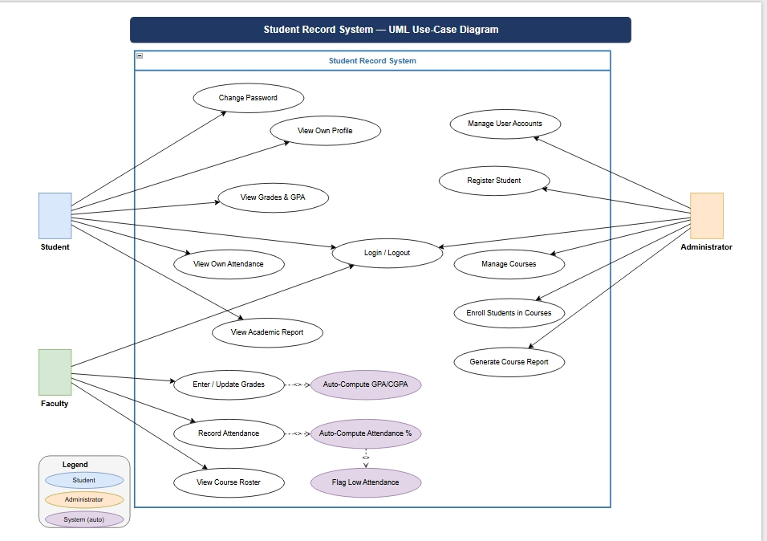

Actor summary:
- Student — views own profile, grades, attendance, and reports.
- Faculty — enters grades and attendance for assigned courses; views course summaries.
- Administrator — manages users, courses, enrollments, and generates institution-level reports.
- System — auto-computes GPA/CGPA and attendance percentages; generates audit logs.

8. Requirements Traceability Matrix (RTM)
Req ID | Short Description | Section | Module | Test Case | Status
SRS-F-001 | Login with valid credentials | 4.1 | Auth & User Mgmt | TC-Auth-01 | N
SRS-F-002 | Logout & session termination | 4.1 | Auth & User Mgmt | TC-Auth-02 | N
SRS-F-003 | Role assignment & RBAC enforcement | 4.1 | Auth & User Mgmt | TC-Auth-03 | N
SRS-F-004 | Admin: manage user accounts | 4.1 | Auth & User Mgmt | TC-Auth-04 | N
SRS-F-005 | User: change own password | 4.1 | Auth & User Mgmt | TC-Auth-05 | N
SRS-F-006 | Admin: register new student | 4.2 | Student Profile | TC-Stu-01 | N
SRS-F-007 | Admin: update/deactivate student profile | 4.2 | Student Profile | TC-Stu-02 | N
SRS-F-008 | Student: view own profile | 4.2 | Student Profile | TC-Stu-03 | N
SRS-F-009 | Admin: search & filter students | 4.2 | Student Profile | TC-Stu-04 | N
SRS-F-010 | Admin: create & manage courses | 4.3 | Course & Enrollment | TC-Crs-01 | N
SRS-F-011 | Admin: enroll students in courses | 4.3 | Course & Enrollment | TC-Crs-02 | N
SRS-F-012 | View course roster | 4.3 | Course & Enrollment | TC-Crs-03 | N
SRS-F-013 | Faculty: enter/update grades | 4.4 | Grade Management | TC-Grd-01 | N
SRS-F-014 | Auto-compute GPA/CGPA | 4.4 | Grade Management | TC-Grd-02 | N
SRS-F-015 | Student: view grades & GPA | 4.4 | Grade Management | TC-Grd-03 | N
SRS-F-016 | Restrict grade entry to assigned faculty | 4.4 | Grade Management | TC-Grd-04 | N
SRS-F-017 | Faculty: record attendance | 4.5 | Attendance | TC-Att-01 | N
SRS-F-018 | Auto-compute attendance % | 4.5 | Attendance | TC-Att-02 | N
SRS-F-019 | Flag low-attendance students | 4.5 | Attendance | TC-Att-03 | N
SRS-F-020 | Student: view own attendance | 4.5 | Attendance | TC-Att-04 | N
SRS-F-021 | Generate per-student academic report | 4.6 | Reports | TC-Rpt-01 | N
SRS-F-022 | Export report to CSV/text | 4.6 | Reports | TC-Rpt-02 | N
SRS-F-023 | Admin: course-level performance report | 4.6 | Reports | TC-Rpt-03 | N
SRS-NF-001 | Response time ≤ 2 s | 5 | Performance | TC-Perf-01 | N
SRS-NF-002 | GPA/attendance data consistency | 5 | Data Integrity | TC-INT-01 | N
SRS-NF-003 | Consistent UI navigation | 5 | Usability | TC-UX-01 | N
SRS-NF-004 | Modular C/C++ codebase | 5 | Maintainability | Code Review | N
SRS-NF-005 | Windows & Linux portability | 5 | Portability | TC-Compat-01 | N
SRS-NF-006 | No data loss on shutdown | 5 | Reliability | TC-Rel-01 | N
SRS-NF-007 | 5,000 records / 50 sessions | 5 | Scalability | TC-Scale-01 | N
SRS-SR-001 | Require authentication | 5.1.2 | Security | TC-Sec-01 | N
SRS-SR-002 | Enforce RBAC | 5.1.2 | Security | TC-Sec-02 | N
SRS-SR-003 | Hash passwords | 5.1.2 | Security | TC-Sec-03 | N
SRS-SR-004 | Validate all inputs | 5.1.2 | Security | TC-Sec-04 | N
SRS-SR-005 | Maintain audit log | 5.1.2 | Security | TC-Sec-05 | N

